Base Layers
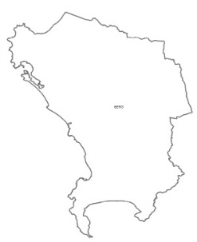 |  |  | Title: Berg Water Man. Area  Date Received: ‎January ‎30,  ‎2014  Source: SANBI BGIS |  |  |  | Description: Shapefile showing the old Berg Water Management Area. Defines the areal extent for all other layers  Contact: Selwyn Willoughby  Email: S.Willoughby@sanbi.org.za
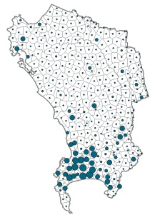 |  |  | Title: Demographics  Date Received: May 28, 2014  Source: CSIR (GAP Data) |  |  |  | Description: Shows the population distribution based on the household size and area ( e.g. rural vs. urban vs. informal settlements)  Contact: Download from web  Web Link: http://www.gap.csir.co.za/download-maps-and-data
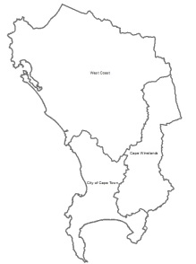 |  |  | Title: District Municipalities  Date Received:‎ February ‎05,  ‎2014  Source: AGIS |  |  |  | Description: Shapefile showing the District Municipalities boundaries.  Contact: Request via website  Web: http://www.agis.agric.za/agisweb/agis.html
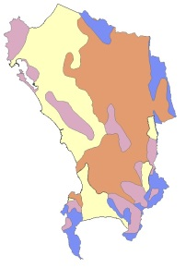 |  |  | Title: Geology  Date Received: ‎February ‎18,  ‎2014  Source: Enpat |  |  |  | Description: Shapefile showing the geology of the area at a Supergroup scale  Contact: Request via web, simplified geology can be downloaded  Web: http://www.agis.agric.za/agisweb/agis.html
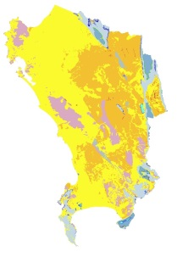 |  |  | Title: Geology Formations  Date Received: ‎March ‎27, ‎2014  Source: Green Cape |  |  |  | Description: Shapefile showing geology of the area at formation scale  Contact: Nisbert Chimboza  Email: nisbert@green-cape.co.za
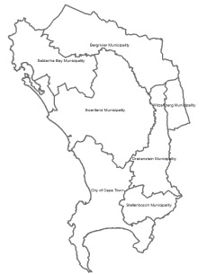 |  |  | Title: Local Municipalities  Date Received: ‎February ‎05,  ‎2014  Source: AGIS |  |  |  | Description: Shapefile showing the Local Municipalities boundaries  Contact: Request via website  Web Link: http://www.agis.agric.za/agisweb/  agis.html
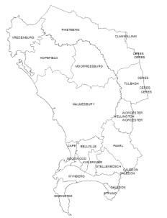 |  |  | Title: Magisterial Districts  Date Received: ‎February ‎05, ‎  2014  Source: AGIS |  |  |  | Description: Shapefile showing Magisterial Districts boundaries  Contact: Request via website  Web Link: http://www.agis.agric.za/agisweb/ agis.html
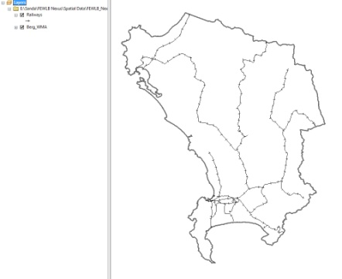 |  |  | Title: Railways  Date Received: ‎ February ‎05,  ‎2014  Source: AGIS |  |  |  | Description: Shapefile showing major railway routes  Contact: Request via website  Web Link: http://www.agis.agric.za/agisweb/  agis.html
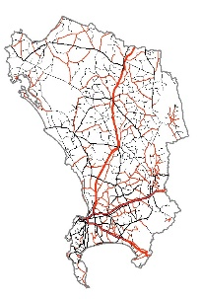 |  |  | Title: Roads  Date Received: ‎February ‎05,  ‎2014  Source: AGIS |  |  |  | Description: Shapefile showing all roads, at all levels (National, Secondary, Arterial etc.)  Contact: Request via website  Web Link: http://www.agis.agric.za/agisweb/ agis.html
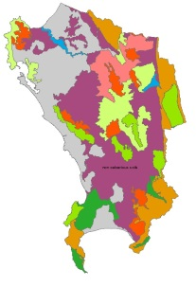 |  |  | Title: Soils  Date Received: February ‎11, ‎  2014  Source: DoA_Elsenburg |  |  |  | Description: Shapefile showing the types of soils in the area. Key Attribute is “LOGDESCR”  Contact: Mike Wallace  Email: MikeW@elsenburg.com
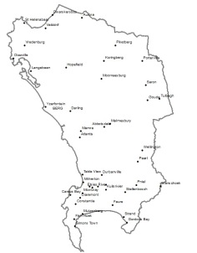 |  |  | Title: Towns  Date Received: ‎January ‎30, ‎  2014  Source: DEA&DP |  |  |  | Description: Shapefile showing major Towns/ Cities  Contact: Andre van der Merwe  Email: Andre.vanderMerwe@westerncape.gov.za
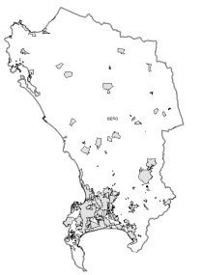 |  |  | Title: Town Boundaries  Date Received: January ‎30, ‎  2014  Source: DEA&DP |  |  |  | Description: Shapefile showing the boundaries of major Towns/ Cities  Contact: Andre van der Merwe  Email: Andre.vanderMerwe@westerncape.gov.za
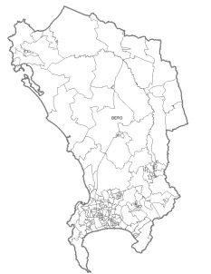 |  |  |  | Title: Wards  Date Received: ‎January ‎30,  ‎2014  Source: DEA&DP |  |  |  | Description: Shapefile showing the ward boundaries  Contact: Andre van der Merwe  Email: Andre.vanderMerwe@westerncape.gov.za
Rasters in Base Layers
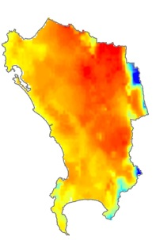 |  |  | Title: AvgTemp Annual  Date Received: ‎January ‎30,  ‎2014  Source: DEA&DP |  |  |  | Description: Raster file showing mean annual temperature  Contact: Andre van der Merwe  Email: Andre.vanderMerwe@westerncape.gov.za
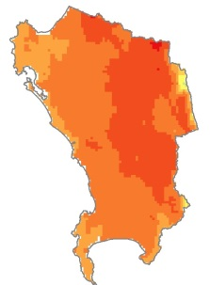 |  |  | Title: AvgTemp Feb  Date Received: ‎January ‎30,  ‎2014  Source: DoA_Elsenburg |  |  |  | Description: Raster showing the average temperature for February  Contact: Andre van der Merwe  Email: Andre.vanderMerwe@westerncape.gov.za
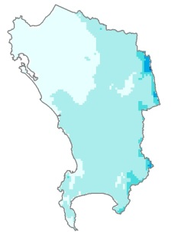 |  |  | Title: AvgTemp July  Date Received: ‎January ‎30,  ‎2014  Source: DoA_Elsenburg |  |  |  | Description: Raster showing the average temperature for July  Contact: Andre van der Merwe  Email: Andre.vanderMerwe@westerncape.gov.za
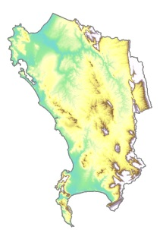 |  |  | Title:Elevation  Date Received: May 28, 2014  Source: SA Wind Atlas |  |  |  | Description: Elevation of terrain at modelling site in [m] above mean sea level  Contact: Download from web  Web Link: http://www.wasaproject.info/  windresourcedataApril2014/
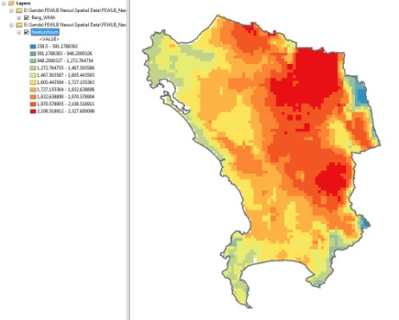 |  |  | Title: Heat Summer Units  Date Received: February ‎11,  ‎2014  Source: DoA_Elsenburg |  |  |  | Description: A raster file showing heat units accumulated in summer. Represented as heat units/ degree days.  Contact: Mike Wallace  Email: MikeW@elsenburg.com
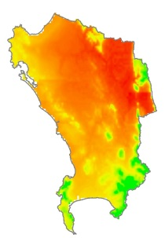 |  |  | Title: PotEvap Feb  Date Received: February ‎11,  ‎2014  Source: DoA_Elsenburg |  |  |  | Description: Raster showing potential evaporation (mm) during February  Contact: Mike Wallace  Email: MikeW@elsenburg.com
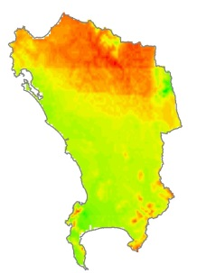 |  |  | Title: PotEvap July  Date Received: February ‎11,  ‎2014  Source: DoA_Elsenburg |  |  |  | Description: Raster showing potential evaporation (mm) during July  Contact: Mike Wallace  Email: MikeW@elsenburg.com
Food Layers
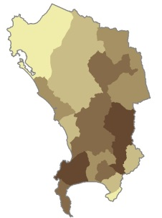 |  |  | Title: Driest Year NPP  Date Received: February ‎11,  ‎2014  Source: DoA_Elsenburg |  |  | Description: Shapefile showing net primary productivity in the driest year  Contact: Mike Wallace  Email: MikeW@elsenburg.com
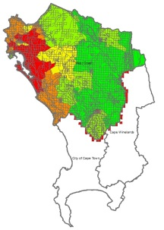 |  |  | Title: Education Index  Date Received: April 10, 2014  Source: DLG_Risk Reduction Planning |  |  | Description: Shapefile showing vulnerability in the West Coast Municipality as factor of Education  Contact: Nabeel Rylands  Email: nabeel.rylands@westerncape.gov.za
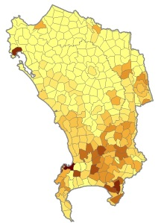 |  |  | Title: Employment Agriculture  Date Received: May 28, 2014  Source: CSIR (GAP Data) |  |  |  | Description: Shows employment estimates for the Agriculture, forestry and fishing Sector  Contact: Download from web  Web Link: http://www.gap.csir.co.za/download-maps-and-data
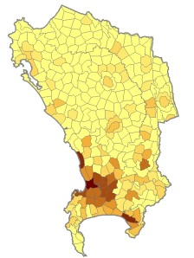 |  |  | Title: Employment Energy  Date Received: May 28, 2014  Source: CSIR (GAP Data) |  |  |  | Description: Shows employment estimates for the Energy Sector  Contact: Download from web  Web Link: http://www.gap.csir.co.za/download-maps-and-data
 |  |  | Title: Employment Manufacturing  Date Received: May 28, 2014  Source: CSIR (GAP Data) |  |  |  | Description: Shows employment estimates for the Manufacturing Sector  Contact: Download from web  Web Link: http://www.gap.csir.co.za/download-maps-and-data
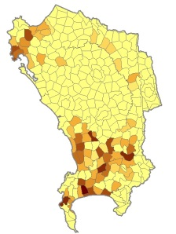 |  |  | Title: Employment Mining  Date Received: May 28, 2014  Source: CSIR (GAP Data) |  |  |  | Description: Shows employment estimates for the Mining and quarrying Sector  Contact: Download from web  Web Link: http://www.gap.csir.co.za/download-maps-and-data
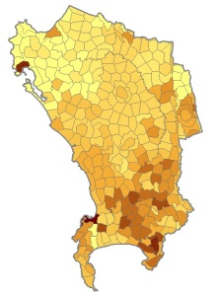 |  |  | Title: GVA Agriculture  Date Received: May 28, 2014  Source: CSIR (GAP Data) |  |  |  | Description: Shows the Gross Value Added Total for the Agriculture, forestry and fishing Sector  Contact: Download from web  Web Link: http://www.gap.csir.co.za/download-maps-and-data
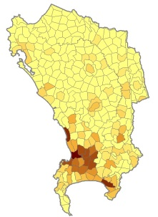 |  |  | Title: GVA Energy  Date Received: May 28, 2014  Source: CSIR (GAP Data) |  |  |  | Description: Shows the Gross Value Added Total for the Energy Sector  Contact: Download from web  Web Link: http://www.gap.csir.co.za/download-maps-and-data
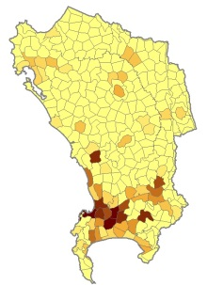 |  |  | Title: GVA Manufacturing  Date Received: May 28, 2014  Source: CSIR (GAP Data) |  |  |  | Description: Shows the Gross Value Added Total for the Manufacturing Sector  Contact: Download from web  Web Link: http://www.gap.csir.co.za/download-maps-and-data
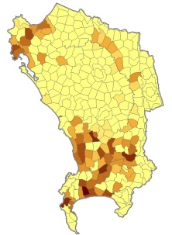 |  |  | Title: GVA Mining  Date Received: May 28, 2014  Source: CSIR (GAP Data) |  |  |  | Description: Shows the Gross Value Added Total for the Mining and quarrying Sector  Contact: Download from web  Web Link: http://www.gap.csir.co.za/download-maps-and-data
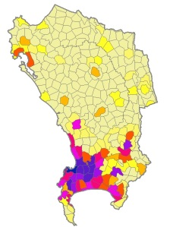 |  |  | Title: GVA Total  Date Received: May 28, 2014  Source: CSIR (GAP Data) |  |  |  | Description: Shows the Gross Value Added Total as a sum of the compensation of employees + Gross Operating Surplus  Contact: Download from web  Web Link: http://www.gap.csir.co.za/download-maps-and-data
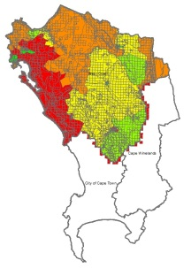 |  |  | Title: Housing Index  Date Received: April 10, 2014  Source: DLG_Risk Reduction Planning |  |  |  | Description: Shapefile showing vulnerability in the West Coast Municipality as factor of Housing  Contact: Nabeel Rylands  Email: nabeel.rylands@westerncape.gov.za
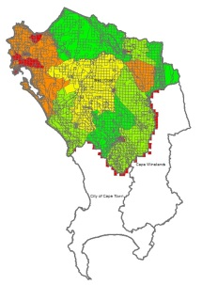 |  |  | Title: Housing Services Index  Date Received: April 10, 2014  Source: DLG_Risk Reduction Planning |  |  |  | Description: Shapefile showing vulnerability in the West Coast Municipality as factor of Housing Services  Contact: Nabeel Rylands  Email: nabeel.rylands@westerncape.gov.za
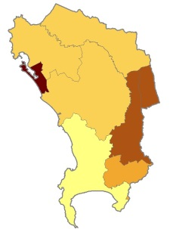 |  |  | Title: Malnutrition  Date Received: ‎ February ‎05,  ‎2014  Source: AGIS |  |  | Description: Shapefile showing malnutrition per local municipality as a factor of weight, stunting and wasting  Contact: Request via website  Web link: http://www.agis.agric.za/agisweb/  agis.html
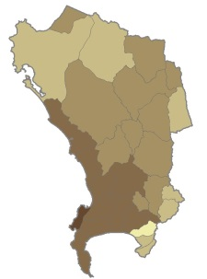 |  |  | Title: Mean Annual NPP  Date Received: February ‎11,  ‎2014  Source: DoA_Elsenburg |  |  | Description: Shapefile showing agricultural mean annual net primary productivity  Contact: Mike Wallace  Email: MikeW@elsenburg.com
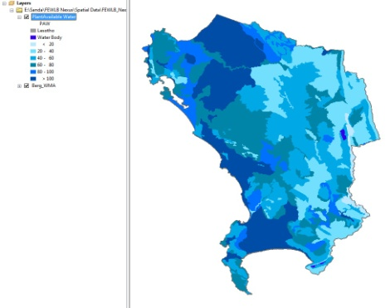 |  |  | Title: Plant Available Water  Date Received: February ‎11,  ‎2014  Source: DoA_Elsenburg |  |  | Description: Shapefile showing values for water readily available for plant growth  Contact: Mike Wallace  Email: MikeW@elsenburg.com
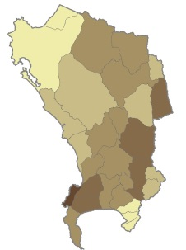 |  |  | Title: Wettest Year NPP  Date Received: February ‎11,  ‎2014  Source: DoA_Elsenburg |  |  | Description: Shapefile showing net primary productivity in the wettest year  Contact: Mike Wallace  Email: MikeW@elsenburg.com
Raster in Food Layers
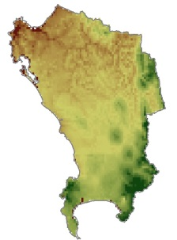 |  |  | Title: moistgrowseas  Date Received: February ‎11,  ‎2014  Source: DoA_Elsenburg |  |  | Description: Raster file showing MOISTURE GROWING SEASON DURATION OF SEASON Based on FAO (1978) Method  Contact: Mike Wallace  Email: MikeW@elsenburg.com
Energy Layers
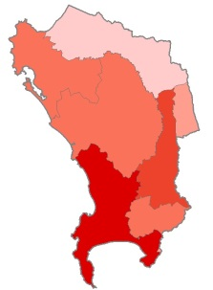 |  | Title: Consumption  perLM  Date Received: ‎ ‎April ‎24, ‎2014  Source: DEA&DP |  |  |  |  | Description: Shapefile showing energy consumption per local municipality  Contact: Andre van der Merwe  Email: Andre.vanderMerwe@westerncape.gov.za
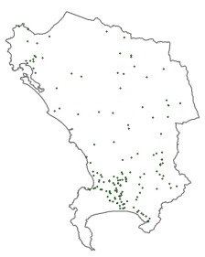 |  | Title: HighVolt Substations  Date Received: April ‎16, ‎2014  Source: Eskom |  |  |  |  | Description: Shapefile showing the distribution of high voltage substations  Contact: Adri De La Rey  Email: dlReyA@eskom.co.za
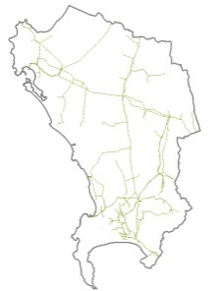 |  | Title: HighVolt Powerlines  Date Received: April ‎16, ‎2014  Source: Eskom |  |  |  |  | Description: Shapefile showing the network of high voltage powerlines  Contact: Adri De La Rey  Email: dlReyA@eskom.co.za
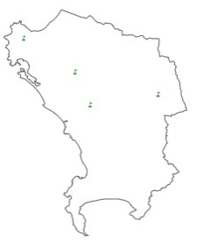 |  | Title: Independent Power Producers  Date Received: April ‎16, ‎2014  Source: Eskom |  |  |  |  | Description: Shapefile showing the distribution of Independent Power Producers  Contact: Adri De La Rey  Email: dlReyA@eskom.co.za
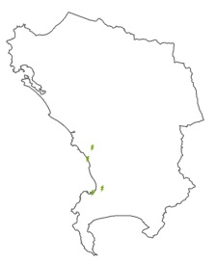 |  | Title: Power Stations  Date Received: April ‎16, ‎2014  Source: Eskom |  |  |  |  | Description: Shapefile showing the distribution of power stations  Contact: Adri De La Rey  Email: dlReyA@eskom.co.za
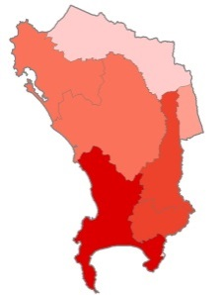 |  | Title: Total Emissions  perLM  Date Received: ‎ ‎April ‎24, ‎2014  Source: DEA&DP |  |  |  |  | Description: Shapefile showing the total GHG emissions per local municipality  Contact: Andre van der Merwe  Email: Andre.vanderMerwe@westerncape.gov.za
Rasters in Energy Layers
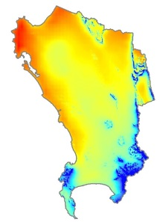 |  | Title: Fixed PV Yield  Date Received: June 03, 2014  Source: EGIS from DEA |  |  |  |  | Description: Raster showing the Photovoltaic (PV) Yield on a fixed tilt optimally inclined plane (kWh(electrical)/kWpeak(installed)/a)  Contact: Download from web  Web Link http://egis.environment.gov.za/  Download.aspx?m=25&amid=66
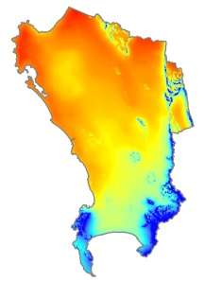 |  | Title: GH Irradiance  Date Received: June 03, 2014  Source: EGIS from DEA |  |  |  |  | Description: Raster showing the total amount of shortwave radiation received from above by a surface horizontal to the ground (kWh/m2/annum)  Contact: Download from web  Web Link: http://egis.environment.gov.za/  Download.aspx?m=25&amid=66
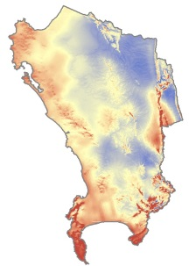 |  | Title: Mean Wind Speed  Date Received: May 28, 2014  Source: SA Wind Atlas |  |  |  |  | Description: Mean wind speed U [ms−1  ] @ 100 m above ground level  Contact: Download from web  Web Link: http://www.wasaproject.info/  windresourcedataApril2014/
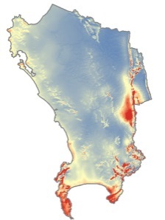 |  | Title: Power Density  Date Received: May 28, 2014  Source: SA Wind Atlas |  |  |  |  | Description: Mean power density P [Wm−2] @ 100 m above ground level  Contact: Download from web  Web Link: http://www.wasaproject.info/  windresourcedataApril2014/
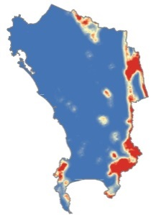 |  | Title: Ruggedness Index  Date Received: May 28, 2014  Source: SA Wind Atlas |  |  |  |  | Description: Site RIX value calculated by WAsP (standard parameter setup)  Contact: Download from web  Web Link: http://www.wasaproject.info/  windresourcedataApril2014/
Water Layers
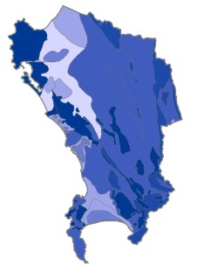 |  |  | Title: Aquifer Yield  Date Received: ‎March ‎27, ‎2014  Source: Green Cape |  |  |  |  |  | Description: Shapefile showing standardized values for the aquifer yield  Contact: Nisbert Chimboza  Email: nisbert@green-cape.co.za
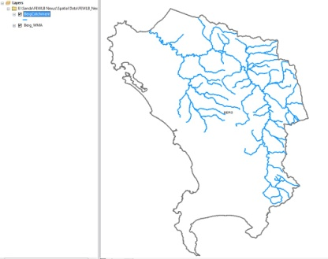 |  |  | Title: Berg Catchment  Date Modified: February ‎11, ‎2014  Source: Modified from DEA&DP |  |  |  |  |  | Description: Shapefile showing the rivers in the Berg River Catchment Modified from the “Rivers.shp”  Contact: Andre van der Merwe  Email: Andre.vanderMerwe@westerncape.gov.za
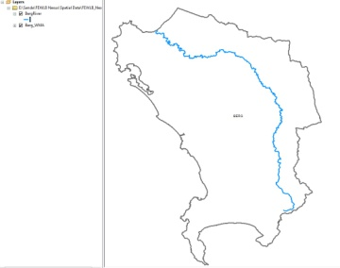 |  |  | Title: Berg River  Date Modified: February ‎11, ‎2014  Source: Modified from DEA&DP |  |  |  |  |  | Description: Shapefile showing the main stem of the Berg River. Modified from “Rivers.shp”  Contact: Andre van der Merwe  Email: Andre.vanderMerwe@westerncape.gov.za
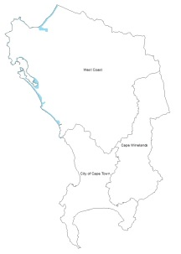 |  |  | Title: Coastal Hazards West Coast  Date Received: April 10, 2014  Source: DLG_Risk Reduction Planning |  |  |  |  |  | Description: Shapefile showing the distribution of coastal hazard lines in the West Coast Municipality  Contact: Nabeel Rylands  Email: nabeel.rylands@westerncape.gov.za
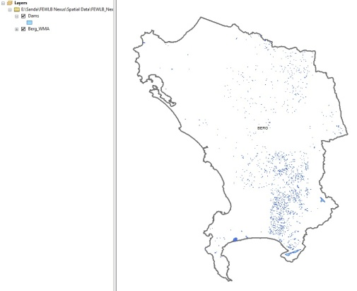 |  |  | Title: Dams  Date Received: ‎January ‎30, ‎2014  Source: DEA&DP |  |  |  |  |  | Description: Shapefile showing all the dams in the area  Contact: Andre van der Merwe  Email: Andre.vanderMerwe@westerncape.gov.za
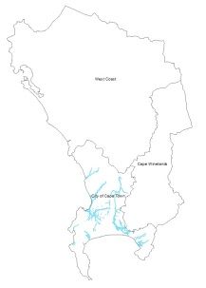 |  |  | Title: FloodLines CoCT  Date Received: June 05, 2014  Source: CoCT_Catchment Storm water and River Management |  |  |  |  |  | Description: Shapefile showing the areas that are flood risks in the CoCT Municipality  Contact: Rod Arnold  Email: Rod.Arnold@capetown.gov.za
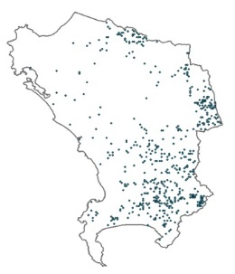 |  |  | Title: GroundWater Abstraction  Date Received: ‎March ‎27, ‎2014  Source: Green Cape |  |  |  |  |  | Description: Shapefile showing the distribution of groundwater extraction points  Contact: Nisbert Chimboza  Email: nisbert@green-cape.co.za
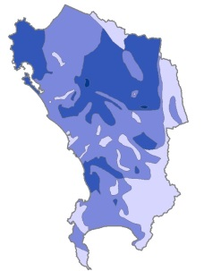 |  |  | Title: Groundwater Quality  Date Received: ‎March ‎27, ‎2014  Source: Green Cape |  |  |  |  |  | Description: Shapefile showing the quality of groundwater - conductivity (mS/m)  Contact: Nisbert Chimboza  Email: nisbert@green-cape.co.za
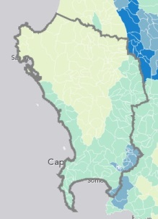 |  |  | Title: High Groundwater Recharge Areas |  |  |  |  |  | Contact: JNel@csir.co.za
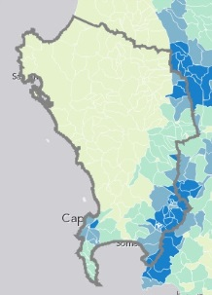 |  |  | Title: High water-yield areas |  |  |  |  |  | Contact: JNel@csir.co.za
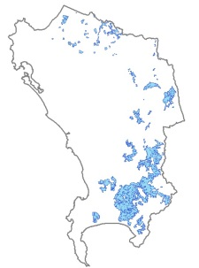 |  |  | Title: Irrigation  Date Received: ‎March ‎27, ‎2014  Source: Green Cape |  |  |  |  |  | Description: Shapefile showing the distribution of commercially irrigated areas  Contact: Nisbert Chimboza  Email: nisbert@green-cape.co.za
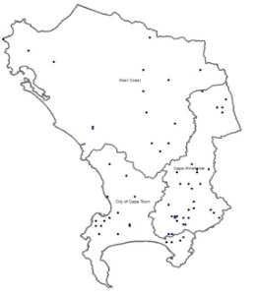 |  |  | Title: Rainfall Stations  Date Received: February ‎11, ‎2014  Source: DoA_Elsenburg |  |  |  |  |  | Description: Shapefile showing the distribution of rainfall stations  Contact: Mike Wallace  Email: MikeW@elsenburg.com
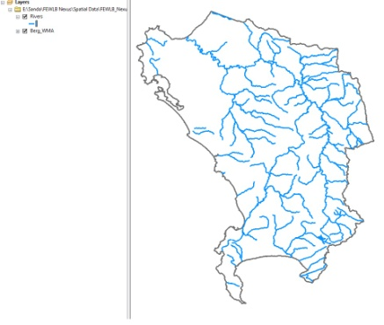 |  |  | Title: Rivers Quaternary  Date Received: ‎January ‎30, ‎2014  Source: DEA&DP |  |  |  |  |  | Description: Shapefile showing all the rivers at a quaternary level.  Contact: Andre van der Merwe  Email: Andre.vanderMerwe@westerncape.gov.za
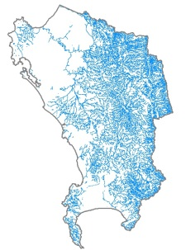 |  |  | Title: Rivers Quinary  Date Received: ‎March ‎27, ‎2014  Source: Green Cape |  |  |  |  |  | Description: Shapefile showing rivers at a quinary level  Contact: Nisbert Chimboza  Email: nisbert@green-cape.co.za
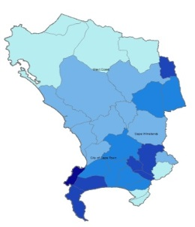 |  |  | Title: Runoff perCatchment  Date Received: February ‎11, ‎2014  Source: DoA_Elsenburg |  |  |  |  |  | Description: Shapefile showing run-off per catchment  Contact: Mike Wallace  Email: MikeW@elsenburg.com
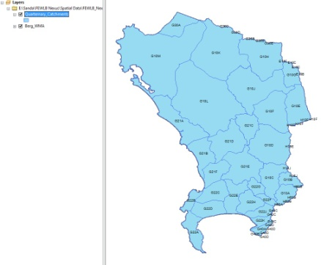 |  |  | Title: Quaternary Catchments  Date Received: February ‎11, ‎2014  Source: DoA_Elsenburg |  |  |  |  |  | Description: Shapefile showing the boundaries of quaternary catchments  Contact: Mike Wallace  Email: MikeW@elsenburg.com
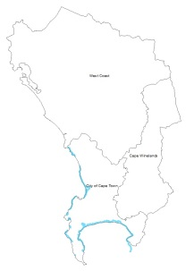 |  |  | Title: Setback Lines CoCT  Date Received: June 05, 2014  Source: CoCT Catchment Storm water and River Management |  |  |  |  |  | Description: Shapefile showing the distribution of coastal setback lines in CoCT Municipality  Contact: Rod Arnold  Email: Rod.Arnold@capetown.gov.za
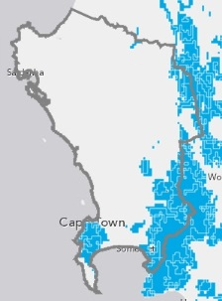 |  |  | Title:Strategic water resource areas  Date Received: April 11, 2014  Source: SANBI |  |  |  |  |  | Layers: Strategic water resource areas  Contact: JNel@csir.co.za
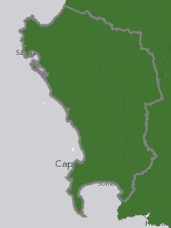 |  |  | Title: Sub WMA  Date Received: April 11, 2014  Source: SANBI |  |  |  |  |  | Contact: JNel@csir.co.za
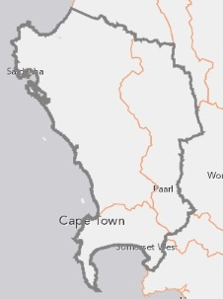 |  |  | Title: Sub WMA (Boundaries)  Date Received: April 11, 2014  Source: SANBI |  |  |  |  |  | Contact: JNel@csir.co.za
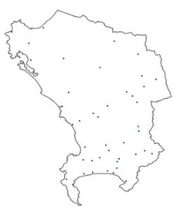 |  |  | Title: Waste Water TreatWorks  Date Received: ‎March ‎27, ‎2014  Source: Green Cape |  |  |  |  |  | Description: Shapefile showing the distribution of waste water treatworks sites  Contact: Nisbert Chimboza  Email: nisbert@green-cape.co.za
Rasters in Water Layers
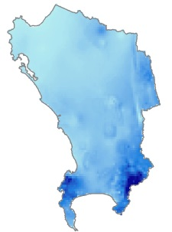 |  |  | Title: MeanRainfall Annual  Date Received: ‎January ‎30, ‎2014  Source: DEA&DP |  |  |  |  |  | Description: Raster file showing average annual rainfall  Contact: Andre van der Merwe  Email: Andre.vanderMerwe@westerncape.gov.za
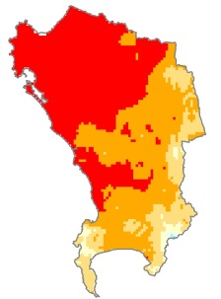 |  |  | Title: MedianRainfall Feb  Date Received: ‎January ‎30, ‎2014  Source: DEA&DP |  |  |  |  |  | Description: Raster file showing the median rainfall values in February  Contact: Andre van der Merwe  Email: Andre.vanderMerwe@westerncape.gov.za
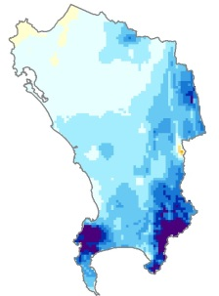 |  |  | Title: MedianRainfall Jun  Date Received: ‎January ‎30, ‎2014  Source: DEA&DP |  |  |  |  |  | Description: Raster file showing the median rainfall values in June  Contact: Andre van der Merwe  Email: Andre.vanderMerwe@westerncape.gov.za
Land Layers
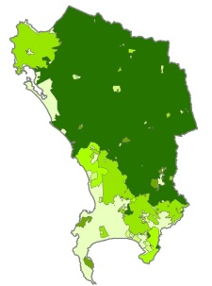 |  |  | Title: Agric. As Main Trade  Date Received: ‎February ‎05,  ‎2014  Source: AGIS |  |  |  | Description: Shapefile showing how much sub-places rely on agriculture & hunting as the main trade  Contact: Request via website  Web link: http://www.agis.agric.za/agisweb/  agis.html
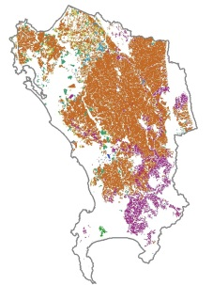 |  |  | Title: Cultivated Fields  Date Received: February ‎11, ‎  2014  Source: DoA_Elsenburg |  |  |  | Description: Shapefile showing the locations and types of cultivated fields  Contact: Mike Wallace  Email: MikeW@elsenburg.com
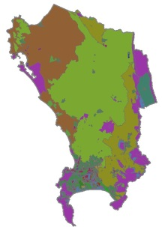 |  |  | Title: Livelihood Zones  Date Received: February ‎05,  ‎2014  Source: DAFF |  |  |  | Description: Shapefile showing the types of livelihood zones (e.g. protected, commercial or urban areas)  Contact: Thulile Dlamini, Food Security Information Unit, Subsistence Farming Directorate  Email: thuliled@daff.org.gov.za
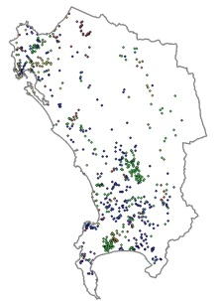 |  |  | Title: Mineral Commodities  Date Received: May 28, 2014  Source: DoA_Elsenburg |  |  |  | Description: Shapefile showing the distribution of mines (working, closed and the unexploited)  Contact: Mike Wallace  Email: MikeW@elsenburg.com
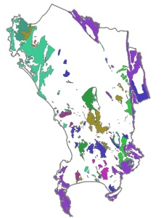 |  |  | Title: Mineral Resources  Date Received: May 28, 2014  Source: DoA_Elsenburg |  |  |  | Description: Shapefile showing the distribution of mineral resources (e.g. Limestone, Phosphate)  Contact: Mike Wallace  Email: MikeW@elsenburg.com
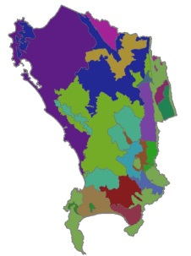 |  |  | Title: RHFA  Date Received: February ‎11,  ‎2014  Source: DoA_Elsenburg |  |  |  | Description: Shapefile showing the boundaries of relatively homogeneous farming areas  Contact: Mike Wallace  Email: MikeW@elsenburg.com
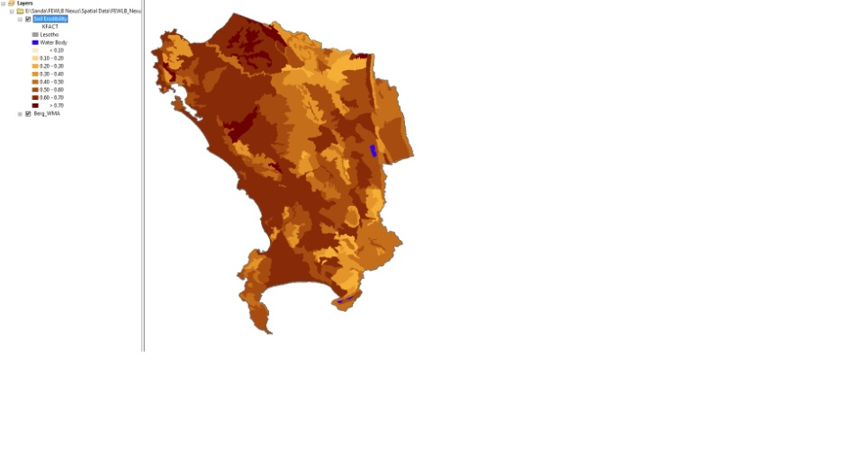 |  |  | Title: Soil Erodibility  Date Received: February ‎11,  ‎2014  Source: DoA_Elsenburg |  |  |  | Description: Shapefile showing the soil erodibility factor where 0.1 represents very low and 0.7 very high  Contact: Mike Wallace  Email: MikeW@elsenburg.com
Biodiversity Layers
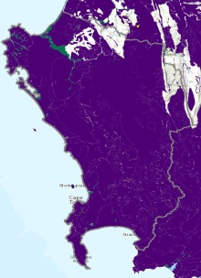 | Title: Biomes 2009
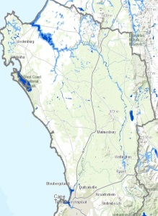 | Title: Estuaries  Date Received: April 11, 2014  Source: SANBI |  |  |  |  |  | Contact: LvNieker@csir.co.za OR  crpetersen@csir.co.za
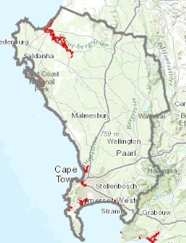 | Title: Estuaries 5m contour  Date Received: April 11, 2014  Source: SANBI |  |  |  |  |  | Contact: LvNieker@csir.co.za OR  crpetersen@csir.co.za
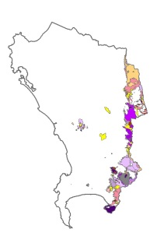 | Title: Fire Hazards  Date Received: June 04, 2014  Source: Cape Nature |  |  |  |  |  | Description: Shapefile showing the distribution of fire hazards and their causes (e.g. people, mechanical, natural etc.)  Contact: Lesley Gibson  Email: lgibson@capenature.co.za
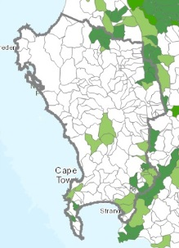 | Title: Fish Sanctuaries  Date Received: April 11, 2014  Source: SANBI |  |  |  |  |  | Contact: JNel@csir.co.za
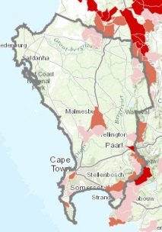 | Title: Fish Sanctuaries (all species)  Date Received: April 11, 2014  Source: SANBI |  |  |  |  |  | Contact: JNel@csir.co.za
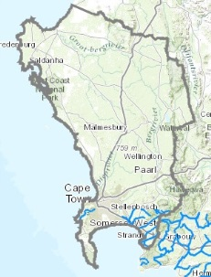 | Title: Free Flowing Rivers  Date Received: April 11, 2014  Source: SANBI |  |  |  |  |  | Contact : f.daniels@sanbi.org.za
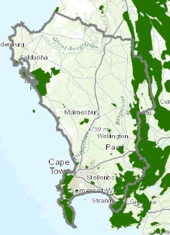 | Title: Formal Terrestrial Protected Areas  Date Received: April 11, 2014  Source: SANBI |  |  |  |  |  | Contact : f.daniels@sanbi.org.za
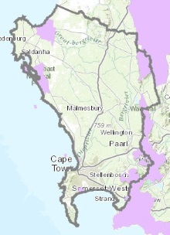 | Title: Important Bird Areas  Date Received: April 11, 2014  Source: SANBI |  |  |  |  |  | Contact: ernst.retief@birdlife.org.za
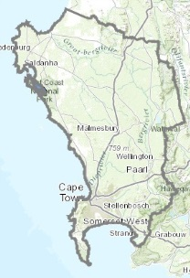 | Title: RAMSAR Sites  Date Received: April 11, 2014  Source: SANBI
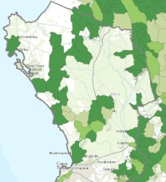 | Title: Rivers FEPAs  Date Received: April 11, 2014  Source: SANBI |  |  |  |  |  | Contact: JNel@csir.co.za
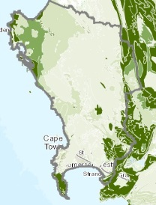 | Title: Terr. Ecosystem Protected Level  Date Received: April 11, 2014  Source: SANBI |  |  |  |  |  | National list terrestrial ecosystems 2011 classified as Critically Endangered, Endangered and Vulnerable  Contact: f.daniels@sanbi.org.za
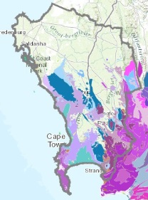 | Title: Vegetation 2009
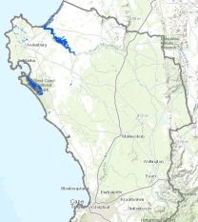 | Title: Wetlands  Date Received: April 11, 2014  Source: SANBI |  |  |  |  |  | Contact: JNel@csir.co.za
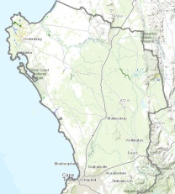 | Title: Wetlands Classification  Date Received: April 11, 2014  Source: SANBI |  |  |  |  |  | Contact: JNel@csir.co.za
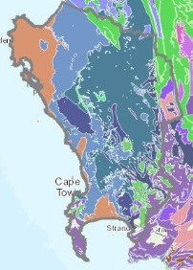 | Title: Wetlands Ecosystem Types  Date Received: April 11, 2014  Source: SANBI |  |  |  |  |  | Contact: JNel@csir.co.za
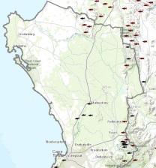 | Title: WMA Fish Points  Date Received: April 11, 2014  Source: SANBI |  |  |  |  |  | Contact : f.daniels@sanbi.org.za
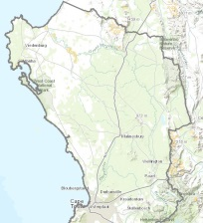 | Title: WMA Wetland Cluster  Date Received: April 11, 2014  Source: SANBI |  |  |  |  |  | Contact: JNel@csir.co.za
Requested Layers
- Hydrological Data and detailed climatology from Roland Schulze
- Groundwater Data from GEOSS
- Land Use Layer from DOA (Mike says we need to send formal request as layer is available)
Unable to source
- Surface water quality data
- Food Security * From Gavin Miller
Next
- Spatial Development Frameworks
- Cadastral boundaries (ERF boundaries)
- River Health *From Cape Nature
- Dependency Ratio * From Gavin Miller
- Abstraction vs. Supposed Water Quantity From Nisbert Chimboza

Asterisk (*): Indicates layers that have not been requested from the indicated holders yet.

